


SGS-Net: An ROI-Guided Graph Convolutional Framework for
Hi-Fi 3D MRI Reconstruction from Sparse Low-Field Scans

A PROJECT PROPOSAL SUBMITTED FOR THE PARTIAL FULFILLMENT OF THE REQUIREMENTS OF THE HIGHER NATIONAL DIPLOMA IN DATA SCIENCE (FULL TIME) PROGRAMME.

H.N. IDDAMALGODA (COHNDDS251F-012)
Higher National Diploma in Data Science
National institute of business management (NIBM)
Colombo, Sri Lanka.
Date of submission – 29th January 2026

Abstract
In the modern world, artificial intelligence, which surpasses human intelligence, is leading the way in various fields. In the medical field, that application creates various ranges based on data. When it comes to Sri Lanka, it simply shows backwardness. This is because the environment with resources that can help the medical field grow is limited. Among the medical equipment available in Sri Lanka, MRI scanners for brain imaging are among them. In Western medicine, MRI data from high-resolution MRIs are typically low-resolution, typically 1.5T in Sri Lanka. However, even at these low-resolution levels, 3D volumetric imaging and Anisotropic Resolution are used to complete the resolution of 2D slices. For this purpose, a deep learning framework called SGS is utilized to reconstruct 3D brain tumor models from 2D slices. In SGS, the missing volumetric data is represented as data that preserves local similarity using GCN, which outperforms CNN. AI deployment uses a Yolo-enabled ROI guide to deploy on standard clinical hardware. Accordingly, the BraTS 2024 Africa dataset is a solution that bridges the technology gap in Sri Lanka with an updatable background. All of this demonstrates the simple clinical application of scientific techniques that can be physically applied through data science in the local healthcare sector.

Keywords: MRI (Magnetic Resonance Imaging), 1.5T (Tesla-Field Strength), Anisotropic Resolution (Vary direction properties), SGS (Sparse Graph based Super Resolution), GCN (Graph Convolutional Network), CNN (Convolutional Neural Network), YOLO (You Only Look Once-Real time image faster detectors), ROI (Region of Interest), BraTS (Brain Tumor Segmentation)
Table of Contents
1. Introduction 4
1.1 Background 4
1.2 Problem Statement 4
1.3 Research Rationale 4
1.4 Research Questions 5
2. Literature Review 5
2.1 Challenge 5
2.2 Key Studies 5
2.3 Research Gap 7
2.3.1 Missing Part 7
2.3.2 Project Filler 7
2.4 Research Ethics 8
3.1 General Objective 8
3.2 Specific Objectives 9
4. Methodology 9
4.1 Research Design 9
4.2 Data Collection 10
4.2.1 Dataset 10
4.2.2 Preprocessing Pipeline 10
4.3 Data Analysis Techniques 11
4.4 Tools and Software 11
4.5 Timeline 11
5. Expected Outcomes and Significance 14
5.1 Anticipated Results 14
5.2 Impact and Significance 14
5.3 Potential for Publication 14
6. Budget and Resources 15
6.1 Computing Resources 15
6.2 Data Resources 15
6.3 Software Tools (Open Source) 15
7. References 15
8. Appendices 19

Introduction

Background
As a semi-developing country in the world economy, it is difficult for the medical sector in Sri Lanka to reach Western technologies. This also affects the use of high-value scanners (3T/7T) for MRI. However, in the current situation, using only data sets with data science applications can be compared to countries with the least developed background, like the Sri Lankan background. Accordingly, here. Technology gaps can be bridged by minimizing equipment costs. According to Musa et al. (2025), working with data from high-end countries is a failure. But here we provide solutions through Edge AI, using efficient algorithms for advanced diagnosis. Thus, Edge AI is a local processing that is connected to data without the Internet. It is the opposite process of the Cloud AI service.

Problem Statement
In the medical field in Sri Lanka, the low values ​​for MRI are. The equipment can be considered a weakness. But even with those values, there is a huge gap between the data required to convert the data images into 2D slices. That is, everything is handled to minimize time and usage. This is a challenge for us as a low-income region. But if we can study it in depth with the existing data, it is a great achievement. Because it is better to use new models to meet maximum needs with minimum facilities than to lag behind using CNN's U-Net as an alternative application.

Research Rationale
Under the HNDDS program, using data science to solve real-world problems, an ROI-guided reconstruction system is used to study anatomy using SGS-Net, which is a low-bandwidth, low-power computer network that can operate without the Internet. It is easy to convert 2D slices to 3D volumes by learning pixels from an image. For this, using suitable data sets, a Graph Convolutional Network is used to convert missing volumetric data into complete data without gaps. This solves problems in the existing environment, accurately and in real time. By connecting to data science, communication between hardware and software is well done.

Research Questions
- How does SGS-Net utilize graph-based structures and resolution grids to reconstruct 3D volumetric MRI scans from 2D slices while maintaining localized ROI accuracy?
- To what extent does SGS-Net improve image fidelity (via SSIM, PSNR, and DSC) compared to traditional models, and how does its Edge-AI integration facilitate deployment on resource-constrained hardware?

Literature Review

Challenge
Many things in the traditional world are implemented in developed countries in the West. However, it is difficult for Sri Lanka, which has a low economic level, to maintain such a situation. If we explain it through the medical field, even the MRI data values ​​​​based on this study take high values ​​​​in high-income countries. It is so difficult to reach those values ​​​​that they exceed twice the values ​​​​here (3T/7T). Accordingly, according to [2] Musa et al., our applications cannot be implemented in developed countries of the world. Because those values ​​​​are very low values ​​​​(1.5T), the hardware gap increases, and the accuracy decreases. However, Kanjoo et al. (2021) show that AI reconstruction can be used to bridge the hardware gap by ignoring the low signal and noise in MRI scanners with minimal values. Accordingly, the reconstruction of the existing data shows that 2D slices can be used in diagnosis with high quality by converting them to 3D. Also, Lopez Scheidt et al. (2023) show that the diagnosis can be made accurately through enhanced low-field images. However, the gap in 2D slices is not solved in the same way.

Key Studies
Author (Year) | Key Findings | Techniques Used | Limitations / Gaps
Musa et al. (2025) | A local model that was rejected by all other models | Comprehensive review | Just the problem solution without an architecture
Wang et al. (2021) | Attention for failed CNN data | Self-Attention Aggregation Network | Non-available clinical data with electrons
Hua et al. (2022) | Graph Networks make bonds better than CNNs | Sparse Graph Attention Network | Gather 2D Super-Resolution, without 3D Volumes
Ma et al. (2024) | GCNs influence for missing data | Graph Convolutional boost of Self-Similarity | Not work on low storage like Edge
Ali et al. (2022) | Bounding Boxes (ROI) for upgrade | Deep Learning Classifier (ROI-based) | Classify without reconstruction
Sanni (2023) | Edge-AI using on real-time diagnosis in low-bandwidth areas. | Edge Software Framework | Framework without aiming at the 3D data
Abolade (2025) | Sub-Saharan MRI data on transformers (Ethnic division) | SegFormer3D+ (Transformer) | Mismatching transformers for older hospital PCs
Ronneberger et al. (2015) | U-Net architecture for image segmentation | CNN (Encoder-Decoder) | long-range spatial dependencies
Isensee et al. (2021) | Complex custom models U-Net | Automated preprocessed parameters | High Computational GPUs for training data
Chen et al.  (2021) | Trans U-Net | Hybrid CNN-Transformer | High-volume memory to the attention mechanism
Qi et al.  (2017) | Deep learning via 3D points | Symmetric functions for unordered data sets. | Good capture from the local structure
Adewole et al. (2024) | Well-developed countries' data matches that of a regressing country | Selected Analysis (BraTS-Africa). | Limited data in the Focus area

Research Gap

Missing Part
As a developing country, anisotropic MRI is not available in Sri Lanka in the traditional 3D imaging method. However, as in Lightweight Edge-AI, using ideas from graph theory can help create a more accurate 3D model. However, current research shows that such a situation is rare. The first step in talking about models in research is to understand how these models hold things together, even across different fields of study. They enable scholars to simplify complex and confusing things that happen in the world. Then, under assumptions about what will happen when specific methods are used. In the absence of models, a large part of what we believe to be true will settle. However, the source research studies that use models to represent the places where they are developed and tested are designed to increase the validity and relevance of the models through multiple tests. The way in which models are constructed, developed, and tested is used to represent the critical aspect of source research projects. This advances the study and demonstrates how concepts become tangible objects.

Project Filler
SGS-Net measurements can fill large gaps in the imaging field by using region-of-interest guidance resources. SGS-Net measurements are integrated with graph transformation network technology in 3D data. The most important function of this new technology is that it helps to improve 3D data from low-field 2D images. Accordingly, the field of 2D images does not provide enough information, so this is needed in the medical imaging field. SGS-Net measurements and graph transformation network technology work together to make medical imaging better. By improving the accuracy of the images provided by medical imaging technology, SGS-Net improves the quality of the data provided and also provides a better expression and deeper understanding of complex medical conditions. This means that the medical community will always be using technology in medical imaging. SGS-Net will not only help doctors get better at diagnosing problems, but it will also go a long way in ensuring that patients can get the care they need. This technology is a deal, it’s new, and it also helps the healthcare system run better for everyone.

Research Ethics
Sparse data Anisotropic resolution requires a minimum of processing time and is less efficient [6]. Thus, although the data resolution is done along a 2D plane, there is no segmentation of deep data. Accordingly, the Z-axis does not exist (Lu et al.). Accordingly, this obscures the detection of small tumor levels by avoiding signals [17]. As a strategy, U-Net, Linear/Cubic methods cannot be used over CNN because they are not practical to apply to local data. As Wang et al. (2021) state, it is also not possible to rely on 2D slices for convolutional standards. Because a large range of missing data cannot be achieved through anatomy. It produces large variations in output.
To avoid this, it is necessary to favor a global study through local pixel processing under all recommendations [11]. Accordingly, the use is changed to using GCN instead of CNN. Hua et al. (2022) proposed a "Sparse Graph Attention Mechanism" to eliminate the distance gap and create relationships that are missed by CNNs within images [5]. Ma et al. (2024) also proposed a unique model that reconstructs missing data in 2D slices using GCNs [12]. Accordingly, the use of expensive research machines in Sub-Saharan Africa has been introduced as an alternative, but since it is difficult to do in our country, modeling small data in low-resource environments, as found by Ayde et al. (2022) [6], is locally practical in our country. However, the range of AI that can be updated in Sri Lanka is limited. However, Veson et al. have confirmed that using low-bandwidth network images for new enhancements [10] is not a good idea. It is also demonstrated in the "Edge AI" proposed by Sanni (2023) as a priority in local settings [9]. Therefore, the application of ROI proposed by Ali et al. (2022) to obtain proper output shows that it can simplify a complex task, thereby reducing computing power and increasing the accuracy of diagnosis [16]. Also, according to Hasan et al. (2025), sharpening model analysis and implementing new architectures using existing methods in deep learning are essential in the medical field [15].
- Research Objectives

General Objective
To develop a framework for 3D volumetric MRI reconstruction from 2D slices using SGS-Net, integrating graph-based structures and resolution grids to enhance the spatial accuracy and structural integrity of anatomical Regions of Interest (ROIs).

Specific Objectives
To evaluate the performance and efficiency of the SGS-Net model by quantifying image fidelity through SSIM and PSNR, validating segmentation accuracy via the Dice Similarity Coefficient (DSC), and optimizing the architecture for Edge-AI deployment on resource-constrained hardware.
Evaluation Metrics
Rank | Measurement | Checking Value
1 | Structural Similarity | 0.9
2 | Peak Signal to Noise Ratio | 30 dB
3 | Dice Similarity Coefficient | 0.85

Methodology

Research Design

First, the SGS-Net model is proposed for use in hospitals in a country like Sri Lanka when creating a 3D MRI volume using synthetic reconstruction. Then, the 3D MRI is combined with the advanced design by removing and recreating the 2D slices, which are then used to remove unwanted parts. Finally, the accuracy of the data is measured using measurement indicators, training the model on the original solid volume dimension.

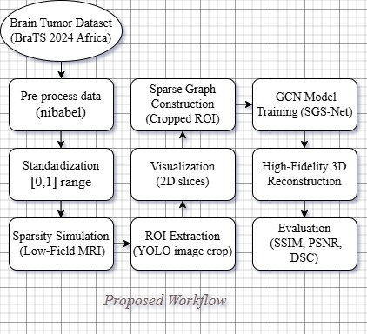

Data Collection

Dataset
The BraTS 2024-Africa dataset [1] was specifically identified by Musa et al. [2]. This dataset includes multi-modal MRI scans that consist of the following types:
T1-Weighted Native, T1-Enhanced Context, T2-Weighted (Fluid/Edema), FLAIR (Highlight Lesions). It is gathered from Sub-Saharan African populations, offering the necessary diversity to assess model robustness in non-Western contexts.

Preprocessing Pipeline
Standardization: Normalized scans are in a [0, 1] range to handle special scanner variance [3].
Sparsity Simulation: To initiate the "Anisotropic Resolution" of older 1.5T scanners, 50% of the slices along the Z-axis will be zero because of the training.
ROI Test (YOLO Simulation): Ali et al. [16] proposed a bounding box mechanism that crops the tumor region, including a 20% context margin, from each slice. This adjustment reduces the input measurements from 240x240 to 128x128, aiming for low memory usage.

Data Analysis Techniques
Under SGS-Net, there are three ways:
- The CNN Branch: A standard Convolutional Neural Network extracts local texture features from each 2D slice.
- The Graph Performance (Novelty): To solve the "Slice Gap" problem, the model constructs a dynamic graph where each slice is a "Node."
- The Graph Convolutional Network (GCN): Information is broadcast along these edges to find the missing data in the empty slices.

Tools and Software
Language: Python 3.9
Deep Learning Framework: PyTorch, PyTorch Geometric, NetworkX (graph layer construction)
Medical Imaging Downloader: IBM Aspera connector (for handling.nii.gz formats)
Hardware: Training will be managed on Google Colab Pro (NVIDIA T4 GPU)

Timeline
The table below provides a clear explanation, while the image displays the Gantt chart.
Phase | Task | Description | Timeline | Deliverables
1. Setup & Imports | Data  Pre-process | Use nibabel for loading NIfTI medical images | Week 1 | Brain tumor data: Converting
 | Data loading | Prepare for graph construction | Week 2 | Identified data
2. Feature Exploring | 2D Slice Visualization | View all MRI modalities (T1, T1ce, T2, FLAIR, Seg) | Week 3 | Visualizations of disease patterns and trends
 | Interactive Slice Browser | Navigate through slices for ROI inspection | Week 4 | Slice Alignment
3. Model Building & Extract | 3D Tumor Visualization | Visualize tumor regions (Necrotic Core, Edema, Enhancing Tumor) | Week 5 | ROI Select to identify the disease exactly
 | Sparse Graph Construction | Nodes represent brain regions, edges represent spatial connectivity | Week 6 | Build a graph from ROI voxels
4. Model Evaluation & Validation | Model Training | ROI-guided Graph Convolutional Network for feature learning | Week 7 | GCN Model performance report
 | Integration & Fusion | Combine multi-scale graph features and skip connections | Week 8 | Refined detail preservations
5. Reconstruction & Reporting | High-Fidelity 3D Reconstruction | Generate 3D MRI from sparse low-field input | Week 9 | High-quality prediction results
 | Calculate metrics | SSIM (structural similarity), PSNR (signal quality), DSC (dice score) | Week 10 | Final project report
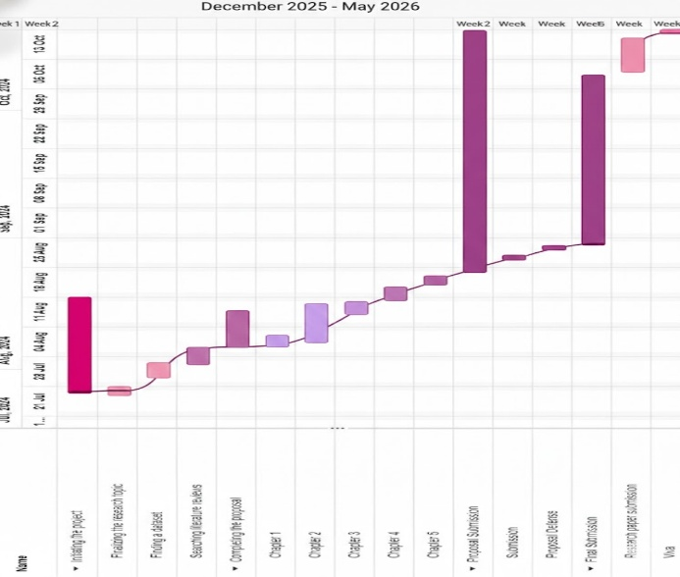

Expected Outcomes and Significance

Anticipated Results
SGS-Net is a fully functional deep learning model that reconstructs 3D MRI volumes from sparse 2D inputs. Specifically, the project's goal is to achieve:
Edge-AI Model: A lightweight PyTorch model file (.pth)
High-Fidelity Reconstruction: A big performance of Dice Similarity Coefficient (DSC) > 0.85 and Structural. To what extent does SGS-Net improve image fidelity (via SSIM, PSNR, and DSC) compared to traditional models, and how does its Edge-AI integration facilitate deployment on resource-constrained hardware? Similarity Index (SSIM) > 0.90 on the BraTS-Africa validation set, proving that the model preserves anatomical integrity without useless standards.
Comparative Analysis Report: Quantifying among “Model Complexity" (U-Net vs. GCN) and "Inference Speed," to hand out a good report.

Impact and Significance
Business/Healthcare Impact: Sri Lankan provincial hospitals are using this project to empower high-quality 3D visualization from older 1.5T scanners. The solution extends the lifespan of medical hardware and, in day-to-day operations, saves healthcare institutions millions of rupees in upgrade costs. It improves "Health Equity" by ensuring that patients in rural areas receive diagnostic quality comparable to that in urban areas.
Skill Expansion: This research develops advanced expertise in Computer Vision, Graph Neural Networks, and Medical Image Analysis. The program’s learning outcomes include applying complex data wrangling (BraTS preprocessing) and rigorous statistical evaluation (paired t-tests on SSIM scores) to a real-world problem.

Potential for Publication
ROI-guided graph network publishing is suitable for specific regions of South Asian domain-shifting innovation. These findings can be presented at international conferences such as the International Conference on Medical Image Computing and Computer-Assisted Intervention Workshops via regional forums such as the NIBM Research Forum, or scholarly discussions on the use of AI.

Budget and Resources

Computing Resources
Expansion Framework: The project will be executed using Python (v3.9) on Google Colab.
Hardware Acceleration: Model training will utilize the NVIDIA T4 GPU provided via Google Colab Pro (approx. cost $10/month), which is sufficient for the lightweight SGS-Net architecture. An Intel Core i5 with 16GB RAM laptop will be used to validate the "Low-Resource" hypothesis.

Data Resources
Primary Dataset: The BraTS 2024-Africa dataset is open-source and free to access after registration on the joint platform without extra cost.

Software Tools (Open Source)
Deep Learning: PyTorch, TorchGeom.
Image Processing: Nibabel, OpenCV, Scikit-Image.
Version Control: Manage code and access to supervise GitHub

References
[1] B. Bonato, L. Nanni, and A. Bertoldo, "Advancing Precision: A Comprehensive Review of MRI Segmentation Datasets from BraTS Challenges (2012-2025)," Sensors, vol. 24, 2024, from
https://pmc.ncbi.nlm.nih.gov/articles/PMC11945730/
[2] A. Musa, R. Prasad, P. Onwualu, and M. Hernandez, "A Systematic Review of Cross-Population Shifts in Medical Imaging Analysis with Deep Learning," Research Square Preprint, Nov. 2025, from
https://www.researchsquare.com/article/rs-8066002/latest
[3] N. Koonjoo, B. Zhu, G. C. Bagnall, D. Bhutto, and M. S. Rosen, "Boosting the signal-to-noise of low-field MRI with deep learning image reconstruction," Scientific Reports, vol. 11, no. 8248, 2021.
https://www.nature.com/articles/s41598-021-87482-7
[4] M. Aggarwal, A. K. Tiwari, and M. P. Sarathi, "Comparative Analysis of Deep Learning Models on Brain Tumor Segmentation Datasets: BraTS 2015-2020 Datasets," Revued' Intelligence Artificielle, vol. 36, no. 6, pp. 863-871, 2022, from
https://www.researchgate.net/profile/Mukul-Aggarwal-3/publication/367229780_Comparative_Analysis_of_Deep_Learning_Models_on_Brain_Tumor_Segmentation_Datasets_BraTS_2015-2020_Datasets/links/6409a110b1704f343fb759e0/Comparative-Analysis-of-Deep-Learning-Models-on-Brain-Tumor-Segmentation-Datasets-BraTS-2015-2020-Datasets.pdf
[5] X. Hua, Z. Du, H. Yu, and J. Ma, "Convolutional neural network based on sparse graph attention mechanism for MRI super-resolution," Biomedical Signal Processing and Control, vol. 80, 2023.
http://arxiv.org/abs/2305.17898
[6] R. Ayde, T. Senft, N. Salameh, and M. Sarracanie, "Deep learning for fast low-field MRI acquisitions," Scientific Reports, vol. 12, no. 11394, 2022, from
https://www.nature.com/articles/s41598-022-14039-7
[7] I. Lopez Schmidt et al., "Diagnostic Image Quality of a Low-Field (0.55T) Knee MRI Protocol Using Deep Learning Image Reconstruction Compared with a Standard (1.5T) Knee MRI Protocol," Journal of Clinical Medicine, vol. 12, no. 1916, 2023, from
https://www.mdpi.com/2077-0383/12/5/1916
[8] I. Abolade, A. Udo, A. Ojo, A. Oyetunji, H. Ajigbotosho, A. Iorumbur, C. Raymond, and M. Adewole, "Domain-Adaptive Transformer for Data-Efficient Glioma Segmentation in Sub-Saharan MRI," arXiv preprint arXiv:2511.02928, Nov. 2025, from
http://arxiv.org/abs/2511.02928
[9] B. Sanni, "Edge-AI Systems for Medical Imaging: Real-Time Diagnostics in Low-Bandwidth and Resource-Constrained Environments," World Journal of Advanced Research and Reviews, 2023.
https://www.researchgate.net/profile/Babatunde-Sanni-2/publication/390793031_Edge-AI_Systems_for_Medical_Imaging_Real-Time_Diagnostics_in_Low-Bandwidth_and_Resource-Constrained_Environments/links/67fe1794df0e3f544f41bd7f/Edge-AI-Systems-for-Medical-Imaging-Real-Time-Diagnostics-in-Low-Bandwidth-and-Resource-Constrained-Environments.pdf
[10] J. E. Venson, F. Bevilacqua, F. Onuki, M. C. d'Ornellas, and A. Maciel, "Efficient medical image access in diagnostic environments with limited resources," Research on Biomedical Engineering, vol. 32, no. 4, pp. 347-357, 2016, from
https://www.scielo.br/j/reng/a/FhbdNVWCrNsn3CbNBZkWQtR/
[11] B. Kainz et al., "Fast Volume Reconstruction from Motion Corrupted Stacks of 2D Slices," IEEE Transactions on Medical Imaging, vol. 34, no. 9, pp. 1901-1913, 2015, from
https://ieeexplore.ieee.org/abstract/document/7064742/
[12] Q. Ma, Z. Lai, Z. Wang, Y. Qiu, H. Zhang, and X. Qu, "MRI reconstruction with enhanced self-similarity using graph convolutional network," BMC Medical Imaging, vol. 24, no. 113, 2024, from
https://bmcmedimaging.biomedcentral.com/articles/10.1186/s12880-024-01297-2
[13] K. Lu, P. Goodwill, B. Zheng, and S. Conolly, "Multi-channel Acquisition for Isotropic Resolution in Magnetic Particle Imaging," IEEE Transactions on Medical Imaging, vol. 37, no. 9, pp. 1989-1998, 2018, from
https://ieeexplore.ieee.org/abstract/document/8239835/
[14] J. D. Rudie et al., "Multi-Disease Segmentation of Gliomas and White Matter Hyperintensities in the BraTS Data Using a 3D Convolutional Neural Network," Frontiers in Computational Neuroscience, vol. 13, no. 84, 2019, from
https://ieeexplore.ieee.org/abstract/document/8239835/
[15] B. T. Hasan, A. M. A. Al-Sabaawi, and Z. J. Al-Araji, "Lightweight Deep Learning for IoT-Based Medical Diagnosis: A Survey," Mesopotamian Journal of Artificial Intelligence in Healthcare, vol. 2025, pp. 244-259, 2025, from
https://mesopotamian.press/journals/index.php/MJAIH/article/view/979
[16] M. B. Ali, I. Y.-H. Gu, A. Lidemar, M. S. Berger, G. Widhalm, and A. S. Jakola, "Prediction of glioma-subtypes: comparison of performance on a DL classifier using bounding box areas versus annotated tumors," BMC Biomedical Engineering, vol. 4, no. 4, 2022, from
https://bmcbiomedeng.biomedcentral.com/articles/10.1186/s42490-022-00061-3
[17] V. Lau et al., "Pushing the limits of low-cost ultra-low-field MRI by dual-acquisition deep learning 3D superresolution," Magnetic Resonance in Medicine, vol. 90, no. 2, 2023, from
https://onlinelibrary.wiley.com/doi/10.1002/mrm.29642
[18] Z. Wang, J. Liu, X. Chen, G. Li, and H. Han, "Sparse self-attention aggregation networks for neural sequence slice interpolation," BioData Mining, vol. 14, no. 10, 2021, from
https://biodatamining.biomedcentral.com/articles/10.1186/s13040-021-00236-z
[19] W. Yu, B. Lei, M. K. Ng, A. C. Cheung, Y. Shen, and S. Wang, "Tensorizing GAN with High-Order Pooling for Alzheimer's Disease Assessment," IEEE Transactions on Neural Networks and Learning Systems, 2020, from
https://ieeexplore.ieee.org/abstract/document/9380155/
[20] K. Kushibar et al., "Transductive Transfer Learning for Domain Adaptation in Brain Magnetic Resonance Image Segmentation," Frontiers in Neuroscience, vol. 15, 2021, from
https://www.frontiersin.org/articles/10.3389/fnins.2021.608808/full

Appendices
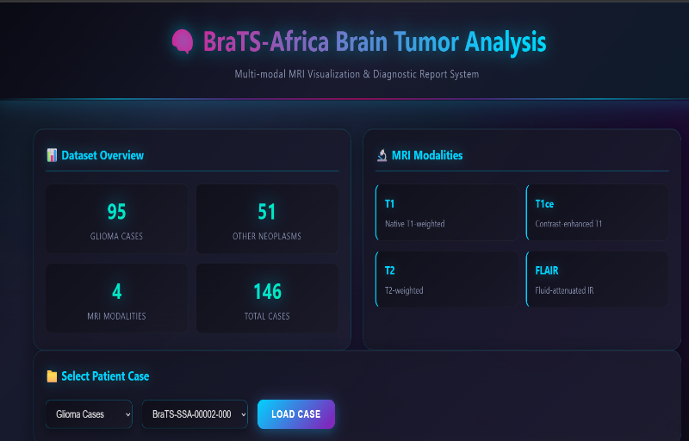
A brief exploration of the dataset and its components.
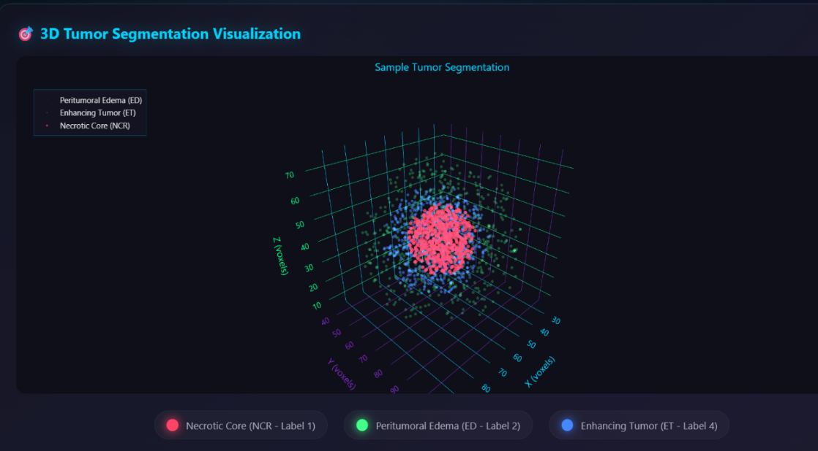
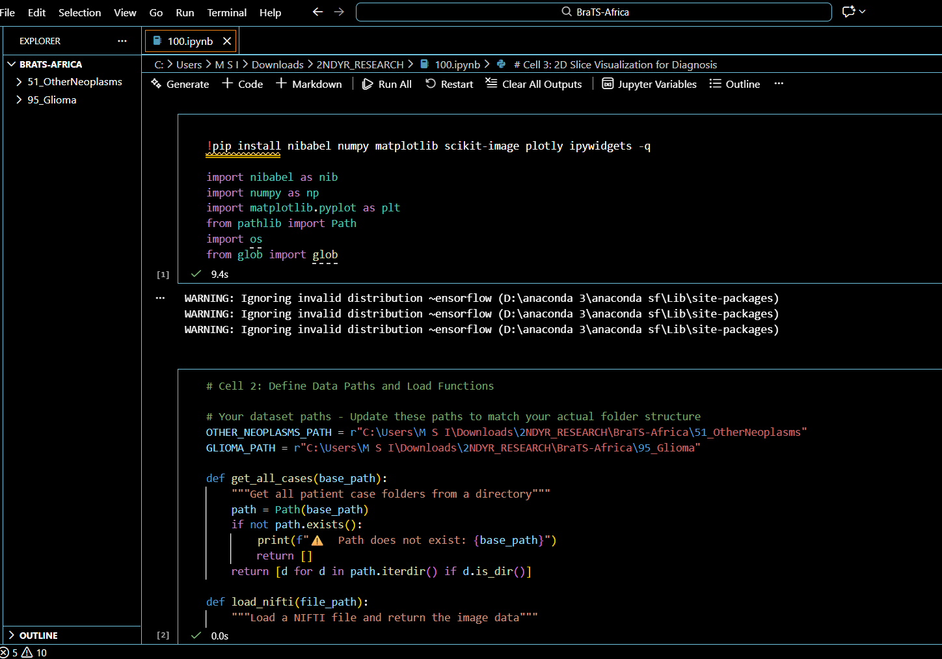
The code that runs in the libraries to get outputs.

The code that generates the specified images.
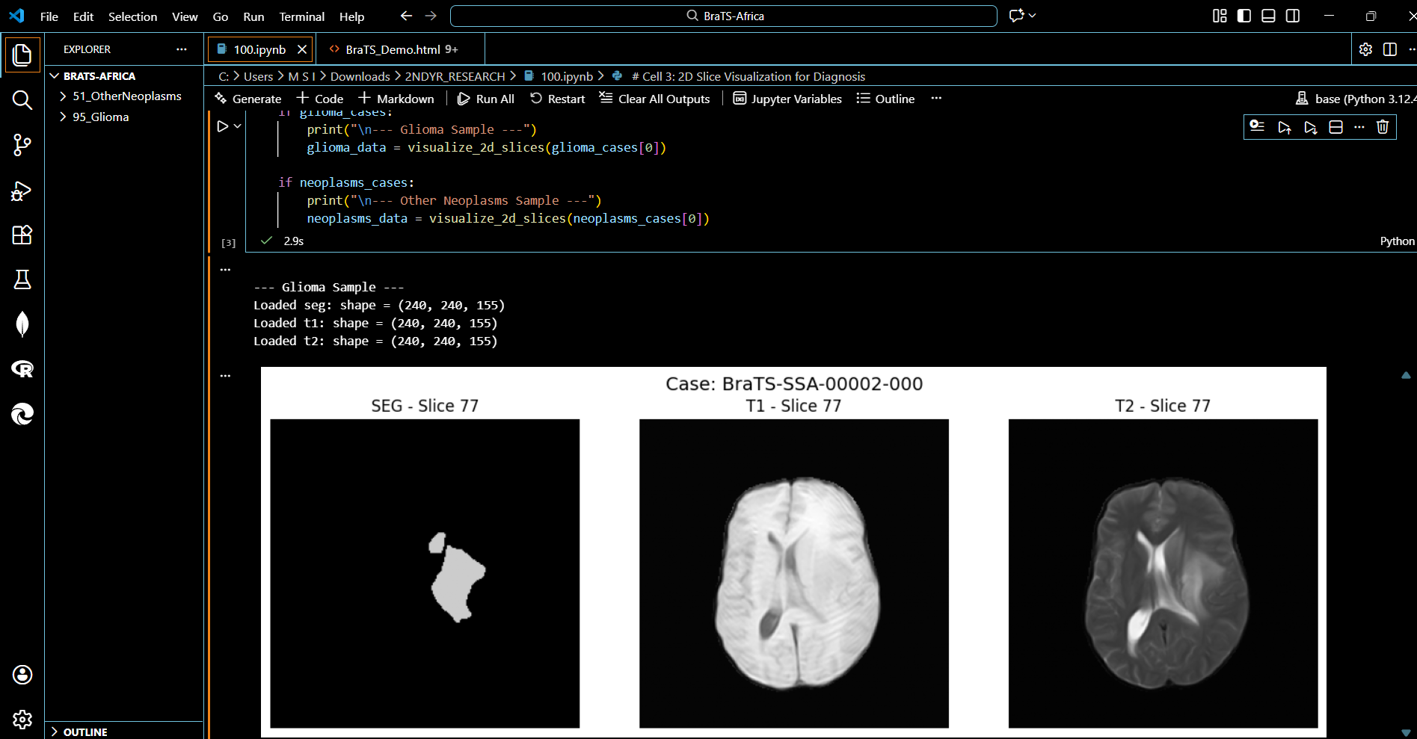
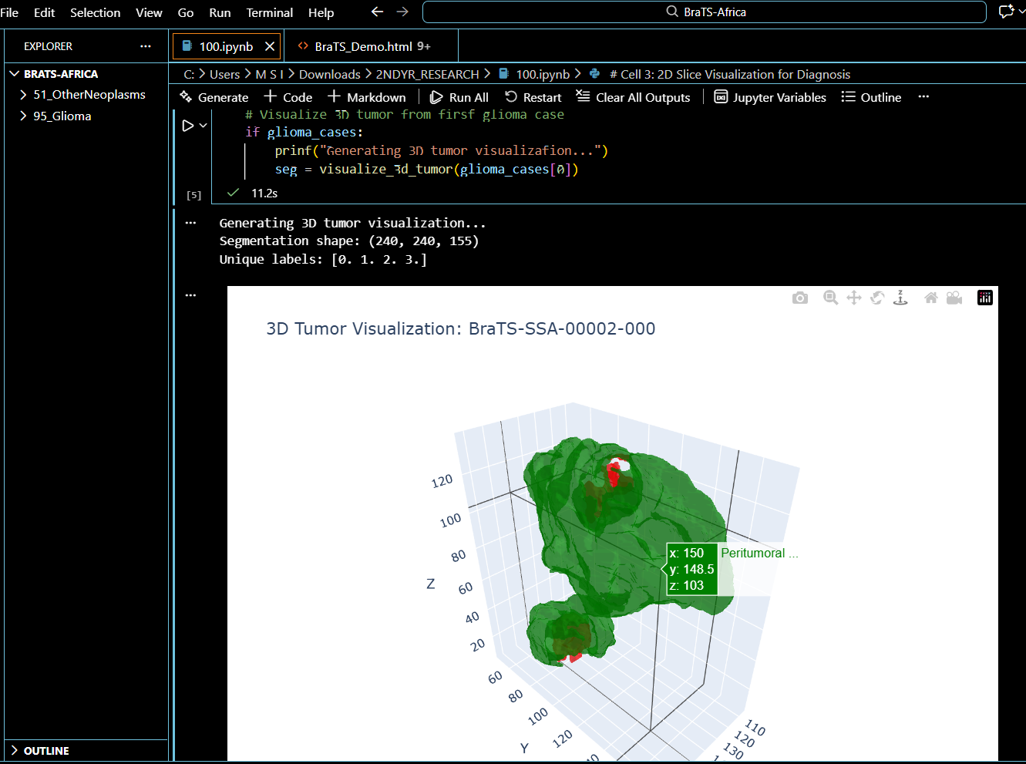
The same patient in different locations.
